Announcement fo Non Suwan Provincial Police Station
Regarding anti-bribery policy (Anti-Bribery Policy)
and not accepting gifts or any other benefits (No Gift Policy) from performing duties. ******************
According to the Organic Act on Prevention and Suppression of Corruption B.E. 2018, Section 128, paragraph one, prohibits any government official from receiving property or any other benefits that may be calculated as income from anyone. In addition to property or benefits which should be obtained according to law Rules or regulations issued by virtue of the provisions of the law, except for the receipt of property. or any other benefits through ethics according to the criteria and amounts specified by the NACC and the Code of Ethics. Police officers 2021, Section 2(2) must be honest and honest. Perform duties according to laws and regulations. The Royal Thai Police Office is transparent and does not show any behavior that is indicative of illegal exploitation. Be responsible for human rights duties and be ready to receive audits and be held accountable. have a good conscience Consider society and item 2(4) consider benefits. The public is more than personal benefit. Have public spirit, cooperate, unite, and sacrifice in making benefits for the public. and creating benefits and happiness for society, together with plans to reform the country in the area of defense and suppress corruption and misconduct. (Revised Edition) Set important reform activities. Activity 4: Develop the Thai bureaucratic system to be transparent and free from profit. Goal 1, Section 1.1, for all government agencies. Announced as an organization that all government officials do not accept gifts and gifts of any kind. from performing duties (No Gift Policy)
Therefore, in order to prevent conflicts between personal and public interests (Conflict of Interest), accepting bribes, gifts, gifts, or any other benefits that affect the performance of duties, guidelines for anti-bribery practices have been established. (Anti-Bribery Policy) and not accepting gifts, gratuities, or any other benefits (No Gift Policy) from performing duties. The details are as follows:

Article 1 This announcement
“Commander” means a person who has the authority to command, supervise, monitor, and inspect police officers under his command.
“Bribe” means property or any other benefit given to a person. to motivate that person Act or not act in any way in the position Whether it is right or wrong according to duty
“Performing duties” means the actions or performance of duties of a government official. In the appointed position or assigned to perform any duty or to act instead in any one role Both in general and specifically as a police officer as required by law. Powers and duties or acts in accordance with the powers and duties specified by law to be the powers and duties of the police.
“Gifts, presents, or any other benefits that affect the performance of duties” means money, property, services, or any other benefits that have value and include tips. which government officials receive in addition to salary and income Benefits from government service in normal cases and affecting decisions, approvals, permissions, or anything else in the performance of duties in a manner that provides dishonest benefits to the gift giver, whether in the past or at the time of receipt or in the future
Article 2: Police officers at all levels shall conduct themselves as follows:
1. Do not ask for advice, do not give or accept bribes, gifts, gifts or any other benefits from performing duties.
2. Do not consent or connive with family members giving or receiving bribes or gifts. or any other benefits to those involved in performing duties
3. The performance of duties must be based on enforcing the law with fairness and taking into account the interests and image of the police. Must not do anything that is a conflict between personal interests. and public benefits such as receiving gifts or any other benefits that affect the performance of duties Using government resources Using stolen property for personal gain, disclosing inside information Compromising official time to do extra work, etc.
4. Reduce the giving or receiving of property or any other benefits in an ethical manner according to the criteria and amounts specified by the NACC by using methods of expression by signing greeting cards, greeting books, condolence cards. or using social media instead of giving things
5. Do not accept, do not tolerate, do not ignore the behavior of accepting bribes, gifts, gifts or any other benefits. from performing duties If any violations are found, the Superintendent/Station Head will be informed immediately.
Section 3 gives the commander the authority to supervise, monitor, and inspect police officers under his supervision. Behave according to this announcement. In the event that an action that violates this announcement is found Report to the Superintendent/Station Head as soon as possible.
Section 4. Anyone found to have acted in violation of this announcement. Complaints/clues can be reported directly to the Superintendent of Nonsuwan Provincial Police Station at Nonsuwan Provincial Police Station. Buriram Province or by telephone 064 224 4925 with information on the complainant/informer It will be strictly concealed and kept secret.
Item 5: In the case of receiving a complaint/clue about personnel under the jurisdiction committing the said offense at the police station. Will carry out a fact check. And if an offense is found, the offender will be punished strictly in accordance with relevant laws, rules and regulations. and deliver matters according to hierarchy further command
Announced on October 1, 2023

Police Colonel 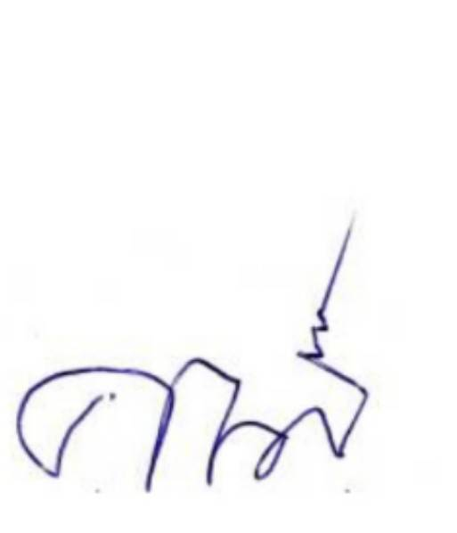
(Kanasanun Suwannasap)
Superintendent of Nonsuwan Provincial Police Station Buriram Province

